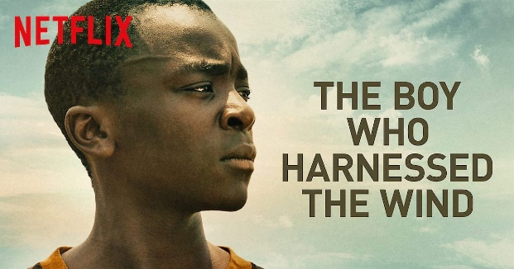

- Watch the movie “The Boy Who Harnessed the Wind”. (The movie is available for viewing on www.netflix.com (You will need a Netflix account holder) and on https://www.youtube.com/watch?v=aADLZwkNm5o

- You can also check out the following TED Talks featuring William as a speaker.
- https://www.ted.com/talks/william_kamkwamba_how_i_harnessed_the_wind?
- https://www.ted.com/talks/william_kamkwamba_how_i_built_a_windmill

- Once you’ve seen the film/ TED talks, you can read about his biography.

William Kamkwamba

William lived in a small family farm near Masitala Village in Malawi, Africa. It was a hard life. The village did not have electricity. The farmers depended on rain to water their crops because they couldn’t power pumps to bring water from the river. There were no lights at night, and no electric appliances. William’s mother and father worked hard to grow enough for the family to eat and to earn the money to send William to the village school. But when a long drought came to Malawi, the crops died. The family had no money to send William to school. He was forced to drop out. He was only fourteen years old.
William knew he needed education. So he went to the very small library in his village. There, he saw a book with a picture of a windmill on the cover. The book was about energy sources, but he couldn’t read it because it was in English. From looking at the pictures, he learned that the windmill used the wind to create electricity. He said to himself, “If someone did this thing, I can also do it.” He decided to build a windmill to bring electricity to his family. Then they could pump water from the river to irrigate their crops. They would have food. They could sell crops to earn the money to send William and his sisters to school. They could have light at night to read and study.
So he looked at the picture on the cover of the book about energy sources, and pictures in one other book he found in the small library. He figured out for himself how the windmill worked, and what parts he would need. There was a junkyard down the long dusty road from his home, and he thought he might be able to find things in the junkyard that he could use to build his windmill. Day after day, William went to the junkyard. As he passed the school every day dragging things from the junkyard behind him, the students in the school would look out the windows, point at him and laugh. People in the village thought William was crazy. But he didn’t let it stop him. He told them "O.K., say what you’re going to say, but I’m still going to do this thing.” He knew he could figure it out. But he also knew that even if he built a windmill, it wouldn’t bring electricity to his home because there were no light bulbs, light switches, or wiring in his parents’ home. He would have to find or make those too, and install them.
It took William about two months to build his first windmill from a broken bicycle, a tractor engine fan, a shock absorber and tree branches. He made light switches from nails, wires, and magnets. The windmill powered a radio and four small light bulbs. When William returned the windmill book to the small village library, the community volunteer who ran the library asked him if he had really built a windmill from the pictures in the hook, and William said yes. A few days later the volunteer and some news reporters showed up at William’s house. The story of his windmill got international attention, which resulted in an invitation to visit the U.S. There, he explained his windmill project at a conference called TED (Technology, Entertainment, and Design). It attracted a lot of attention to William and his windmill. It’s not every day that a fourteen year old boy figures out from pictures how to build a windmill and bring electricity to a village!
A documentary film was made about William and with a co-author he wrote a book about his windmill project. He was invited to attend a college prep school in Johannesburg, South Africa and then to attend Dartmouth College in the U.S. He graduated from Dartmouth in 2014 and has continued his work to bring electricity and water to the villages of Malawi. You can read more about him in his book “The Boy Who Harnessed the Wind”.
- Read the questions about William’s life. You will have to infer some of the answers, so be prepared to back up your opinions. (You might want to use some of the following key ideas to help you answer the questions. Answers will vary!)

- Private vs. free public education system  - Crop irrigation/ farming  - Famine/ starvation/ poverty  - Confidence/ motivation/ concern/  - Lack of opportunity/ perseverance  - Fame/ Recognition/ Self-improvement  - Dream big/ achieve goals | 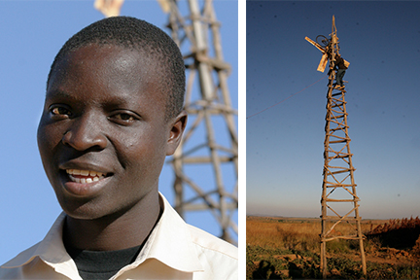

- Choose 5 of the following questions and submit your answers to your teacher.

- What did you think of the film/ talk? What aspects stood out?
- How would you describe William Kamkwamba? What characteristics of William were most essential to his eventual success in building the windmill?
- What are some of the challenges that William faced?
- How did William learn about windmill capabilities and how to actually build a mill?
- There is an English- language proverb “Necessity is the mother of invention”. While a windmill is not a new invention, do you think this proverb played a role in William’s circumstances?
- In which geographical place does the movie take place?
- Malawi is an extremely poor nation. What are the causes of this poverty and what exacerbates it? How might these causes be overcome?
- Why was William forced to drop out from school, and what does it tell you about the education system in Malawi?
- How would you characterize William’s relationship with his father?
- Which of the reasons for bringing electricity to his home do you think motivated William the most?
- Why would no one before William have tried to build a windmill for the village?
- Quite a few people influenced how William’s achievement became known, and also influenced how his life changed afterward.
List three people from those listed in the biography that you think had the most influence on William’s life. Then choose the one who you think was most influential and explain why.
- What can you do to help your community?

- MAKE IT PERSONAL: Choose an inspirational person & write a short paragraph (4-5 lines) explaining why & how this person has influenced you. (Focus on the influence, not just on the person!)
(Who makes an “inspirational person”? People who have made a lasting contribution towards creating a better world. People who have inspired others by their various achievements, attitudes and values. The person of your choice could also be a family member or a celebrity.)

