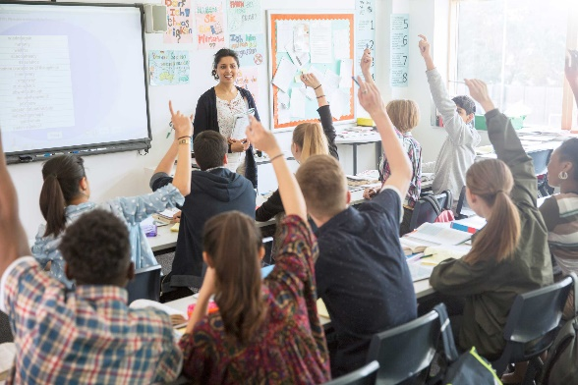
Methodology
Class # 6 (April 17th)
TEACHING TEENAGERS
- Read pages 14- 16 from your booklet.
What are the characteristics of today’s teenagers?

What should we do to teach teenagers effectively?

What shouldn’t we do?

- Watch the following video (length: 03:25)
https://www.youtube.com/watch?v=U6u5_QaJRRM
“Teaching teens how to want to learn.”
BEFORE YOU WATCH:
Complete:
Teenagers are …………………………… , …………………………… , ……………………………
Teenagers like …………………………… , …………………………… , ……………………………
WHILE YOU WATCH:
Complete the diagram:
The key to motivating teens in the classroom

What is the K.I.S.S. method? Explain it briefly.
……………………………………………………………………………………………………………………………………………………….
……………………………………………………………………………………………………………………………………………………….
AFTER YOU WATCH:
- Think of an example of the reward and consequence system.

- Think of an example of an activity that would promote participation.

- Explain how you would explain to your students the reasons for doing a particular activity and the steps they would have to follow to accomplish it.

- Watch the following video. (length: 03:41)
https://www.youtube.com/watch?v=-vpqMJNYYEo
“Teaching Teenagers. How to get their attention and keep it.”
Tips the speaker suggests:
TIP

EXPLAIN IT:

_________________________________________________________________________

_________________________________________________________________________

_________________________________________________________________________

TIP

EXPLAIN IT:

_________________________________________________________________________

_________________________________________________________________________

_________________________________________________________________________

TIP

EXPLAIN IT:

_________________________________________________________________________

_________________________________________________________________________

_________________________________________________________________________
- Watch the following video. (length: 02:59)
https://www.youtube.com/watch?v=wzF3gqcotNE
“Teaching Teens. Main Principles.”
BEFORE YOU WATCH:
Answer this question:
Why do teenagers tend to lack impulse control, demonstrate irrational behavior and often make decisions based on feelings rather that logical thinking?

WHILE YOU WATCH:
What are the principles we should take into account when teaching teenagers? What do they mean? Explain them briefly and / or give examples.
- Include …………………………………………………………………………………………………………………………….
………………………………………………………………………………………………………………………………………….
- Have …………………………………………………………………………………………………………………………………
………………………………………………………………………………………………………………………………………….
- Respect …………………………………………………………………………………………………………………………….
………………………………………………………………………………………………………………………………………….
- Give ……………………………………………………………………………………………………………………………………
………………………………………………………………………………………………………………………………………….
- Be ………………………………………………………………………………………………………………………………………
………………………………………………………………………………………………………………………………………….
AFTER YOU WATCH:
What other features do teenagers have?
*
*
*

